Gabriela García de Cortázar G.

Architectural Association

**Covacevic, Gaggero, Medina, Echeñique and Gonzalez, 1972**

This architectural firm was established in 1971 for the sole purpose of designing one building over a period of only 275 days. Despite its brief existence, its significance for Chilean architecture is paramount, both in terms of the specific building designed by the collective and because of the individual relevance of each architect. This super-firm was put together by Miguel Lawner and Jorge Wong, from the CORMU (Urban Development Corporation), following the direct instruction of the then president, Salvador Allende, with the objective of designing the UNCTAD building.

The UNCTAD III (third United Nations Conference on Trade and Development) was to be held in Santiago in May 1972, and as Chile lacked an existing space to host it, the required 40,000 square metres building had to be hastily constructed. This presented a challenge that would demand an exceptional articulation of legal, human, and technical resources. The establishment of an ad-hoc architectural practice and the selection of a recently vacated plot in downtown Santiago, among other strategies, made this building central not only in architectural terms, but also urban, social and, later, historical ones.

Architects of diverse origins and affiliations composed the ad-hoc firm, drafted from practices that were mainly engaged with public urban projects. José Covacevic studied architecture at the Universidad de Chile, graduating in 1961. After graduating, he studied for two years in Italy and founded the firm Cárdenas Covacevic Farrú Arquitectos, who would lately design the Chilean Congress building (1988). He was one of the founders of the magazine AUCA, and has taught at the school of architecture of the Universidad de Chile for over sixty years. Hugo Gaggero studied architecture at the Universidad Católica. Among other things, he participated in the design of the Naval School in Valparaíso (by Mario Perez de Arce and Hugo Errazuriz, developed between 1957 and 1975) and, together with Margarita Pisano designed one of the San Borja towers in 1969. José Medina graduated from the Universidad de Chile in 1963 and in 1966 worked in Eero Saarinen’s office in the United States. Upon his return to Chile, he joined Miguel Lawner’s firm BEL Arquitectos, mainly working in the Inés de Suárez urban renewal. After the coup d’état in 1973 he would be exiled to Spain. Juan Echeñique studied architecture at the Universidad Católica. He practised in association with José Cruz Covarrubias, and together they would author buildings such as the Chilean Embassy in Buenos Aires, Argentina (1966-9). Sergio Gonzalez graduated as an architect from the Universidad de Chile. He was an active member of the Communist Party, taught at the Universidad de Chile, and worked with Gonzalo Mardones Restat. Between 1953 and 1957 he was a member of parliament for the Communist Party.

The UNCTAD building, after its inauguration in May 1972, had a contested life. Following a short life as cultural centre, it would then pass on to become the seat of government for the military junta under the command of Augusto Pinochet, from 1973 to 1982, after which it housed the Ministry of Defence. Although democracy returned in 1990, the building would have to wait until 2007, when a public competition was held to redesign the building as cultural centre. Today it is the Gabriela Mistral Cultural Centre.

**List of works as collective**

1972 UNCTAD

**Selected works as individuals**

*José Covacevic (together with José Cárdenas and Raúl Farrú)*

1962 University Centre Playa Ancha, Valparaíso

1980 Valparaiso regional government building, Valparaiso

1991 Croatian Social Club, Santiago

*Hugo Gaggero*

1957-1970 Naval School, Valparaiso *(with Mario Perez de Arce et al)*

1969 Tower 18, San Borja urban renewal, Santiago *(with Margarita Pisano)*

*José Medina (with BEL arquitectos)*

1970 First prize, Inés de Suarez renewal

1979 3M offices, Madrid

*Juan Echeñique (with José Cruz Covarrubias)*

1969 Chile Embassy, Buenos Aires

1980 Office building in Pedro de Valdivia st., Santiago

1986 IBM building, Santiago

*Sergio González (with Gonzalo Mardones R.)*

1964 Campus Antumapu Universidad de Chile, Santiago

1967 Villa Olímpica, Santiago

**References and further readings**

Eliash, H. (1989) *Arquitectura y Modernidad en Chile / 1925-1965*, Santiago: Ediciones Pontificia Universidad Católica de Chile.

Herrera, Felipe (1972) “Edificio sede para UNCTAD III: centro cultural metropolitano de Santiago”, en Auca n° 22, pp. 57-72

Talesnik, Daniel: “Monumentality and resignification: the UNCTAD III building in Chile”, in Del Real, Patricio and Helen Gyger (2013) *Latin American modern architectures: ambiguous territories,* New York: Routledge.

Valdés Phillips, Héctor (1972) “Los arquitectos y la UNCTAD III” en CA n° 9, p. 7-8

www.gam.cl

**Visual material**

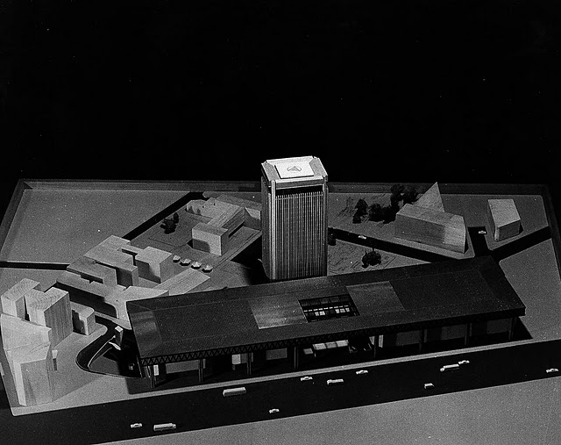

Figure 1: Final model, 1971 (http://ordenartificial.wordpress.com/2012/09/06/unctad-iii-arquitectura-contradictoria-borrador/)

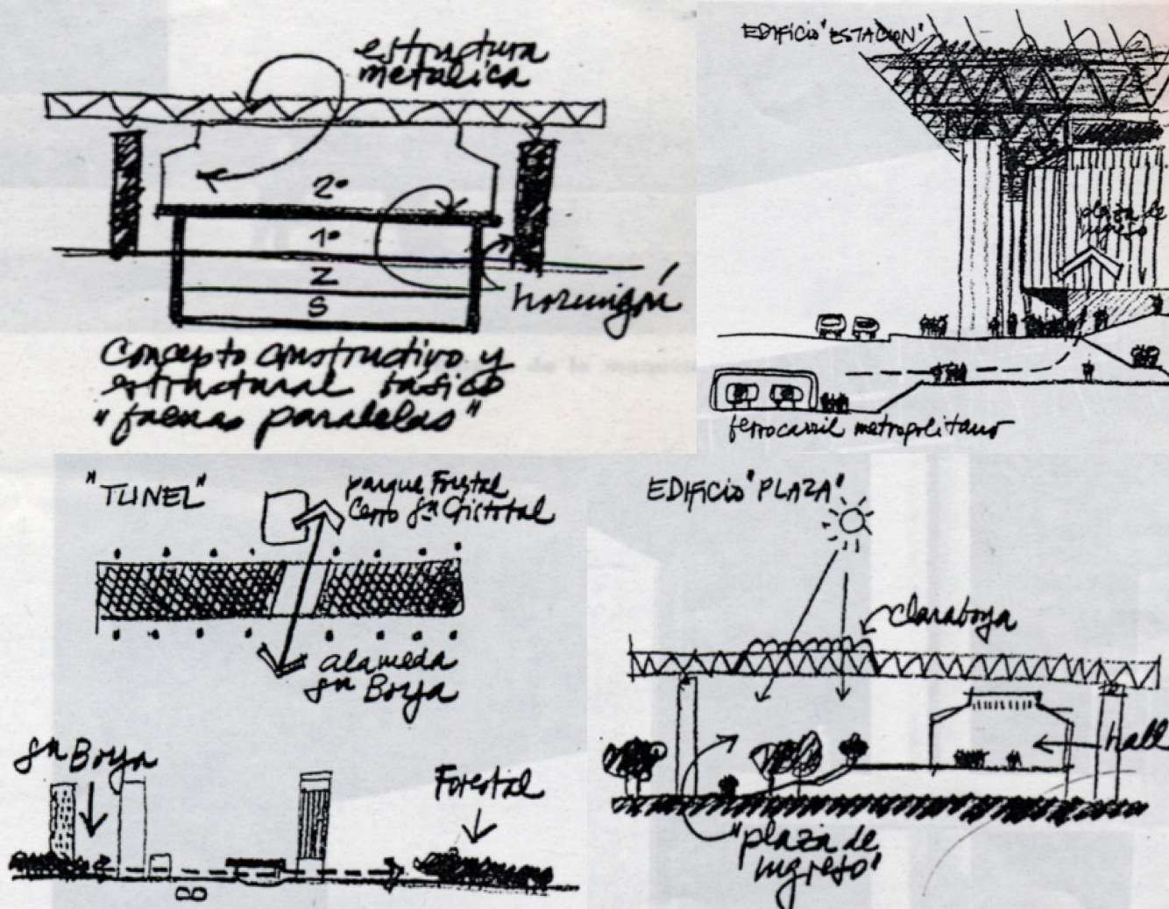

Figure 2: Conceptual sketches (clockwise, from upper left side): the 'parallel forms' concept; the ‘station building’; the ‘tunnel building’; the ‘piazza building’ (from http://ordenartificial.wordpress.com/2012/09/06/unctad-iii-arquitectura-contradictoria-borrador/)

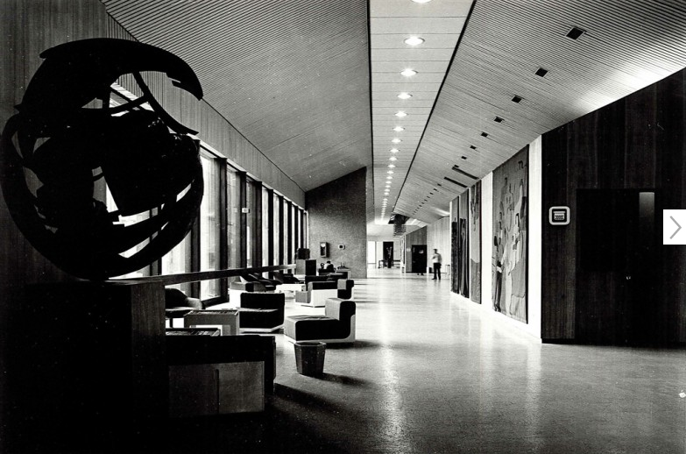

Figure 3: the UNCTAD III building, interior view, 1972 (http://www.gamtv.cl/?p=728)

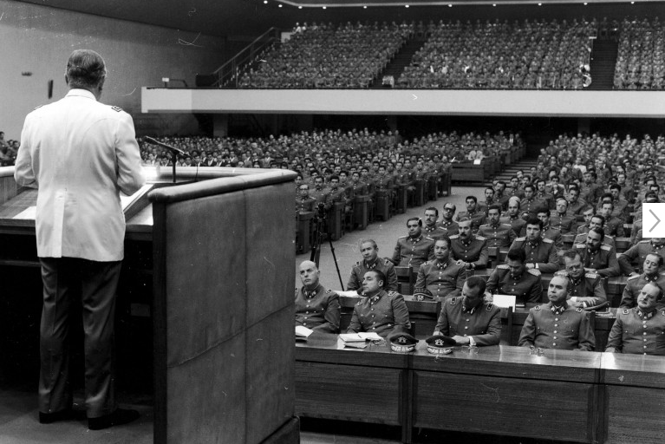

Figure 4: The building under military use is re-named 'Diego Portales' (http://www.gamtv.cl/?p=1948)

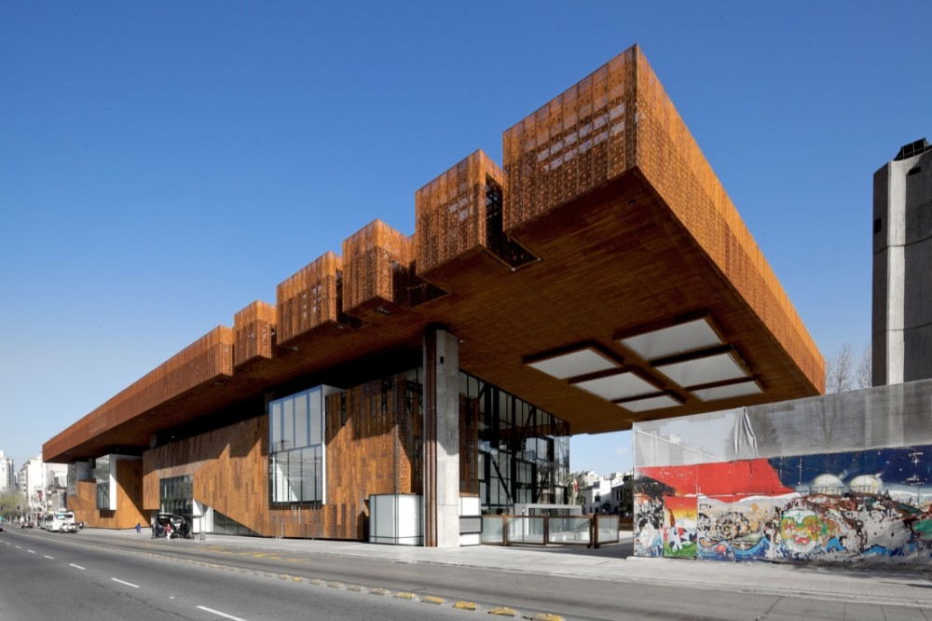

Figure 5: the renovated building, 2010: GAM cultural centre by Cristian Fernandez and Lateral (from http://www.plataformaarquitectura.cl/2010/08/31/centro-cultural-gabriela-mistral-cristian-fernandez-arquitectos-lateral-arquitectura-diseno/1287177876-gam-fdez-lat-087/)

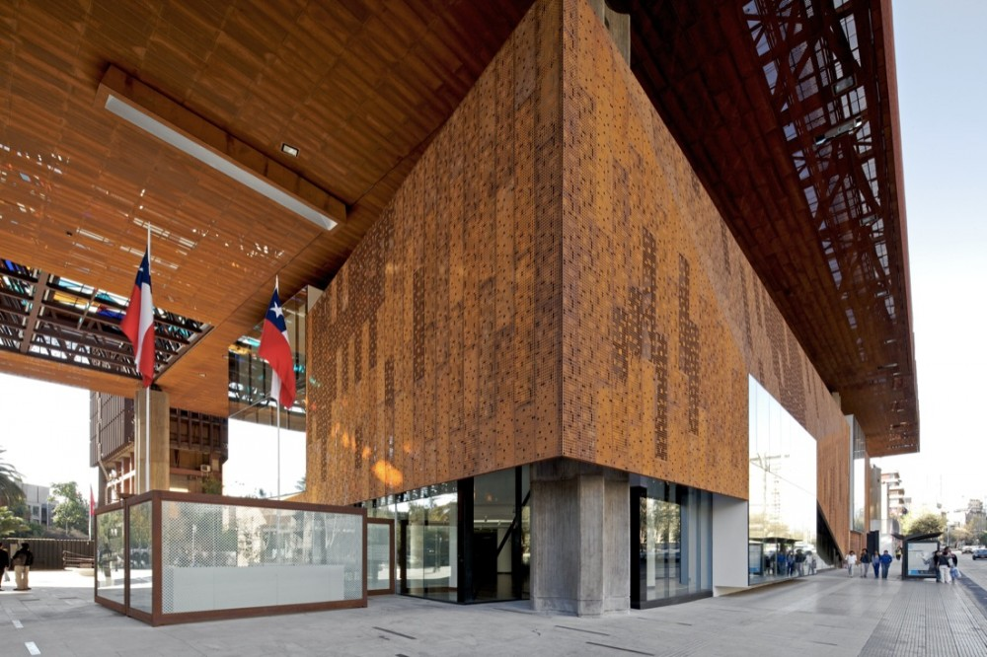

Figure 6: GAM cultural centre, 2010, Fernandez and Lateral (from http://www.plataformaarquitectura.cl/2010/08/31/centro-cultural-gabriela-mistral-cristian-fernandez-arquitectos-lateral-arquitectura-diseno/1287177793-gam-fdez-lat-024/)

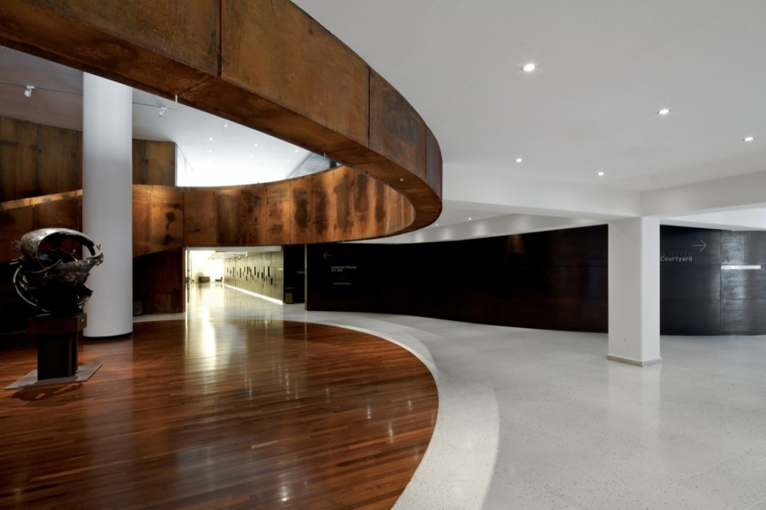

Figure 7: interior of GAM (from http://www.plataformaarquitectura.cl/2010/08/31/centro-cultural-gabriela-mistral-cristian-fernandez-arquitectos-lateral-arquitectura-diseno/1287177816-gam-fdez-lat-038/)